**Guide: Mr.Jinson Devis**

**Date: 13.02.2019**

**UML Diagrams – AUTOSHOP**

**Structural Diagrams**

**Class Diagram**

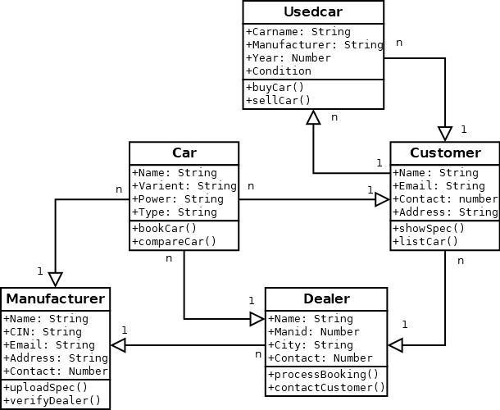

**Used Vehicle**

**Object Diagram**

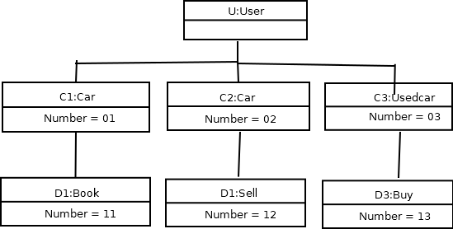**Component Diagram**

C3:Used Vehicle

C2:Vehicle

C1:Vehicle

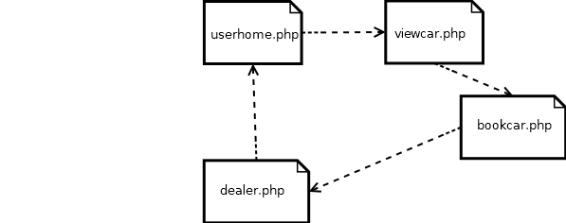

Book vehicle.php

View vehicle.php

**Deployment Diagram**

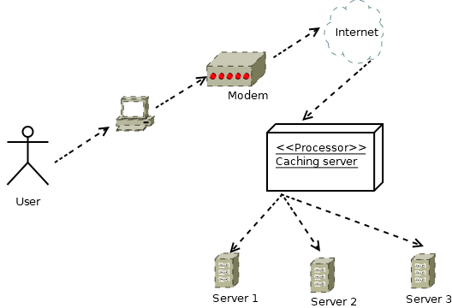

**Behavioral Diagrams**

**Use case diagram**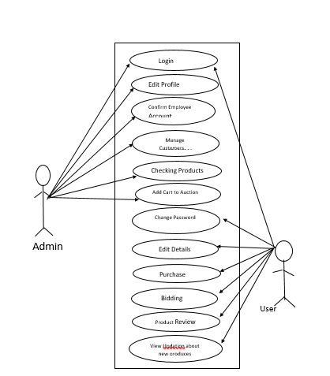

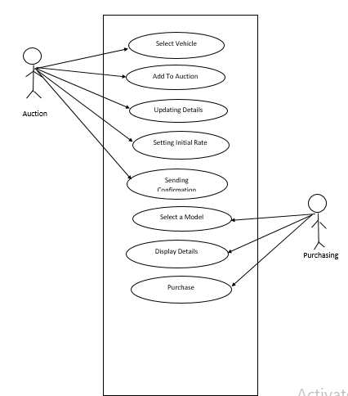

**Collaboration Diagram**

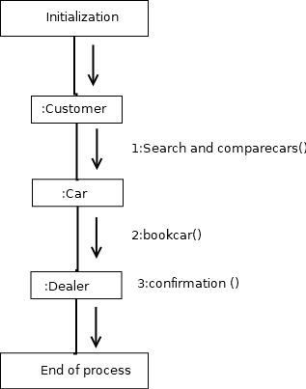

Compare vehicles()

:vehiclee

Book vehicle()

**Sequence Diagram**

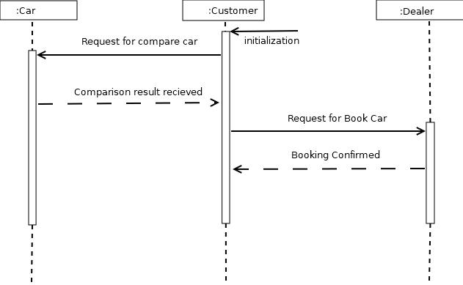

vehicles

vehicles

Vehicless()

**Statechart Diagram**

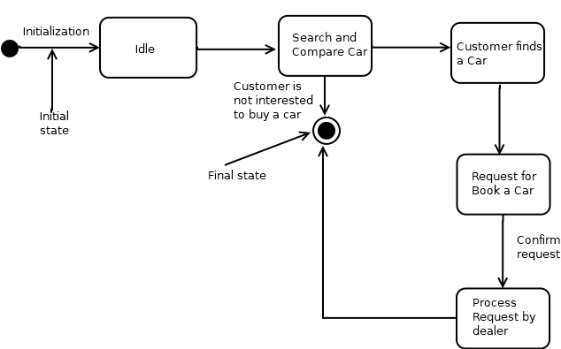

Book vehicle

the vehicle

vehicles